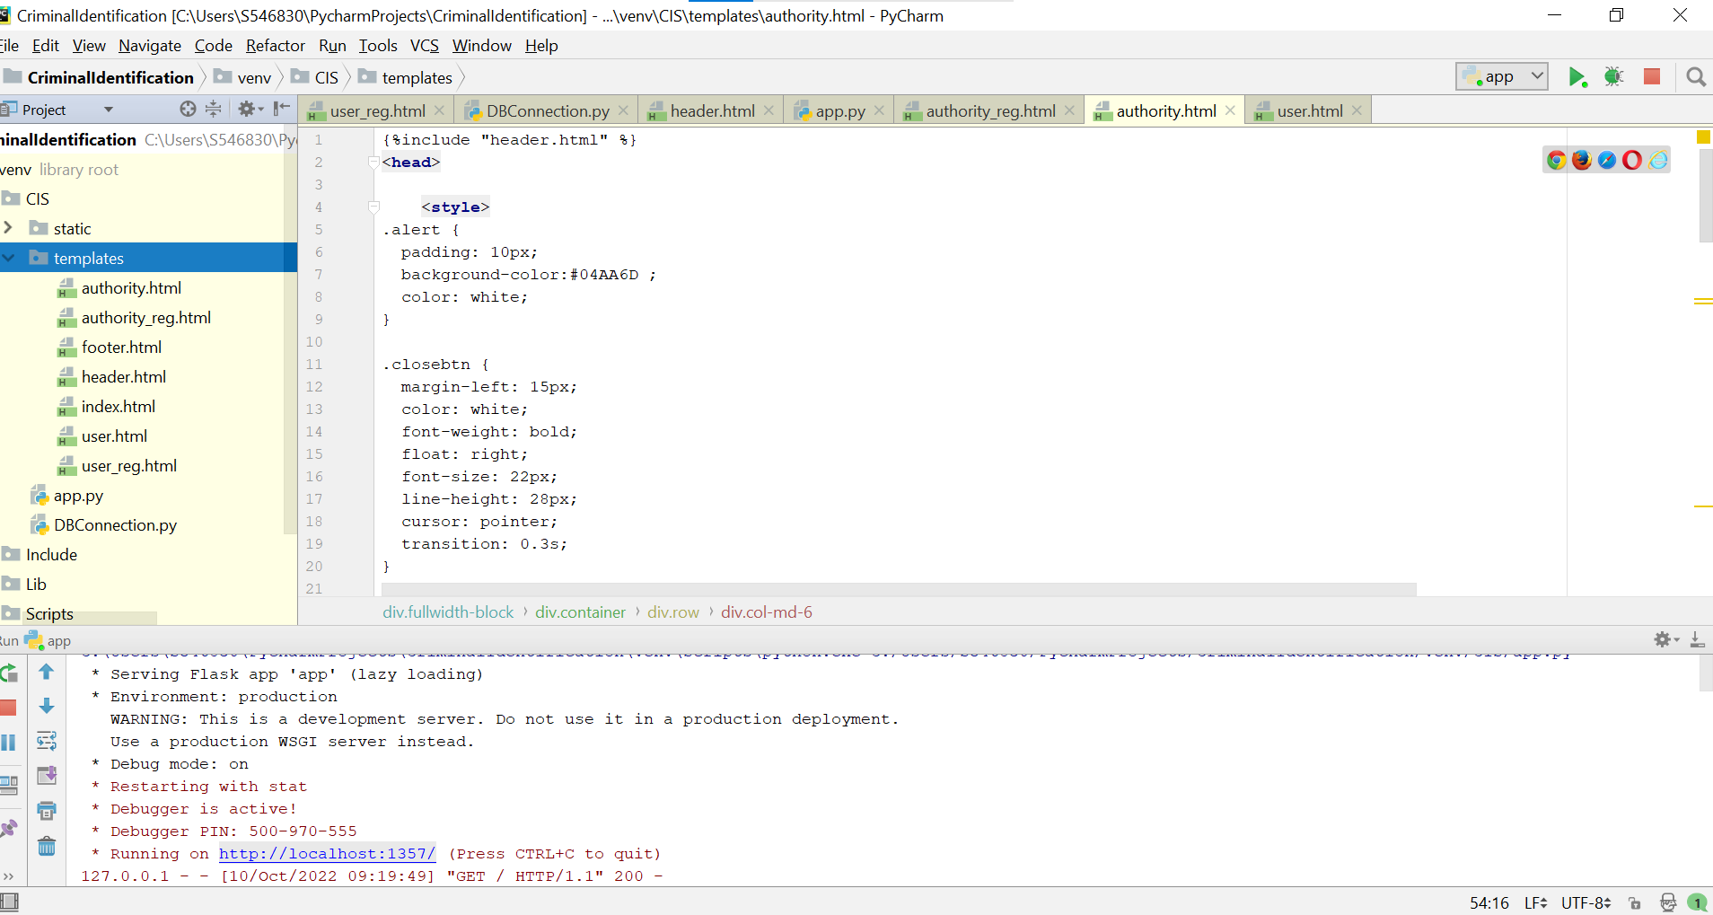
For this week, we have created the authority and user registration pages.

Created the app.py, authority.html, authority_reg.html, user.html, user_reg.html, index.html, header.html files under template folder in Pycharm.
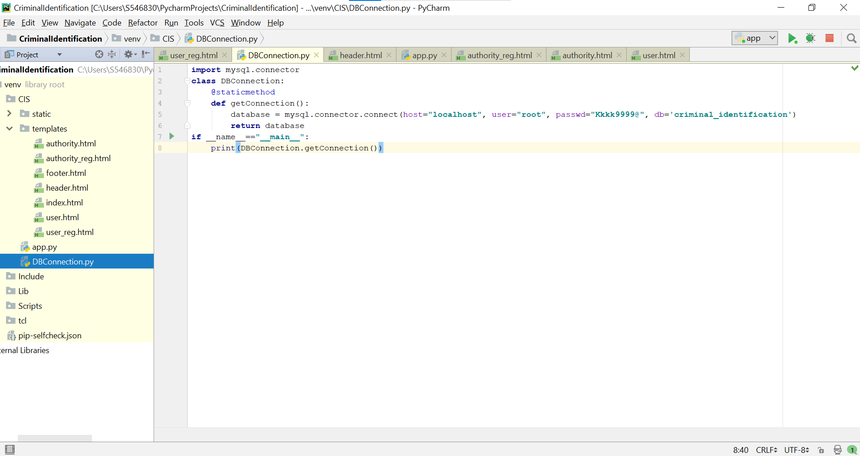
Also established Database Connection.
Created the DBconnection.py file under CIS folder.In the DBconnection.py file mention password to connect our python code to database.To do this we need have the module named mysql-connector-python version 8.0.26
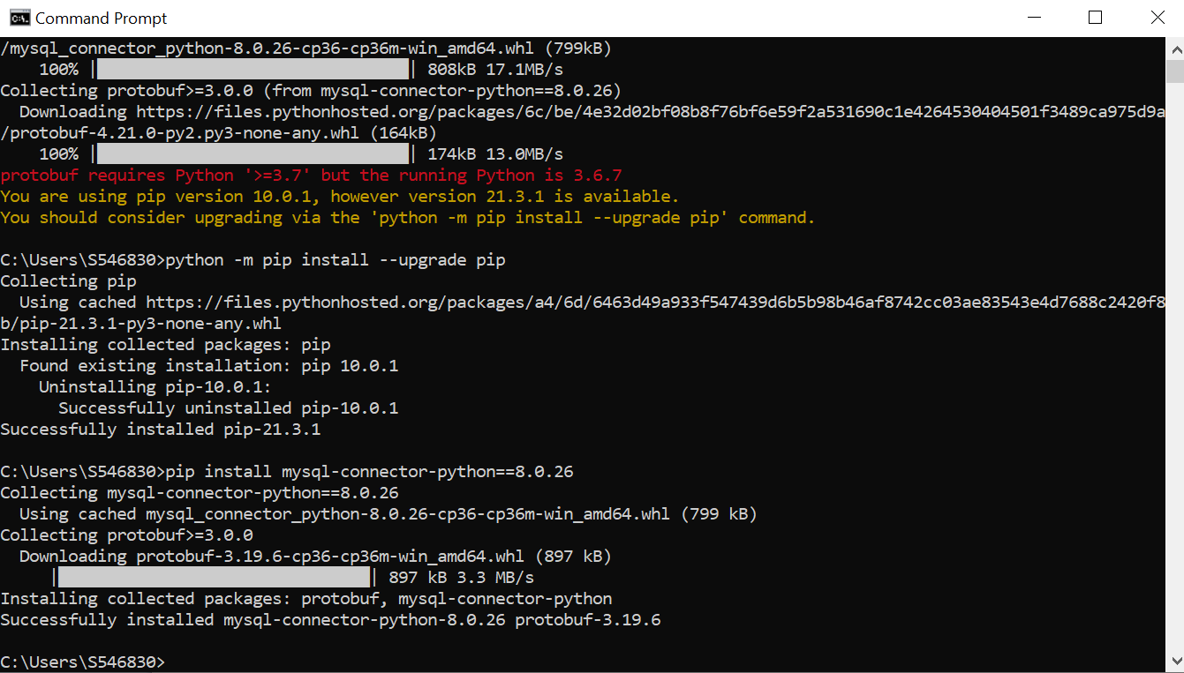
Command -> pip install mysql-connector-python==8.0.26

